**Coin Printing with Aluminum Foil**

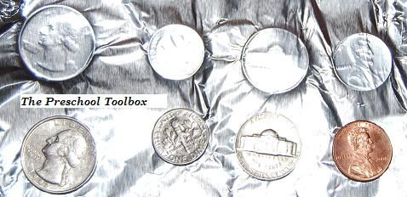

Materials needed: A variety of coins, tape or poster putty, and aluminum foil.   
  
Let your children make coin prints using aluminum foil. With tape or poster putty, adhere a variety of coins to a table or hard surface.

Let the children place the aluminum foil over the coins and use their sense of touch to find them. Ask the children to rub the coin with their finger. As the children rub the coin, the imprint of the coin will appear.

It is fun to see the different faces/backs of the coins in the aluminum foil!

The PreSchool Toolbox [www.preschooltoolbox.com](http://www.preschooltoolbox.com)