**Kindergarten-Grade 1 Money Math Activities**

**C:\Users\Sue Sandage\AppData\Local\Microsoft\Windows\Temporary Internet Files\Content.IE5\O476RN58\MC900212087[1].wmfPlaying Bank**

Here's a more challenging game for older preschoolers. You'll need dice and enough pennies, nickels, dimes, and quarters for each player. The object of the game is for each player to acquire a quarter. Put all the coins in the center of the table. This is the bank. Take turns rolling the dice. Call out the number on the dice (or you can count them out together). Each player takes that number of pennies. For example, if you roll a number 4, take four pennies. Each time a player accumulates five pennies, he/she can trade them in for a nickel. Each time a player has two nickels, trade them in for one dime, and so on. The game ends when each player has a quarter.

**Buy a Snack**

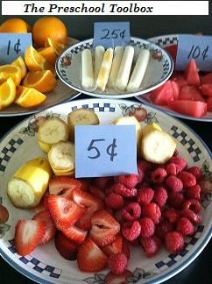Materials needed: an assortment of healthy snack options, pretend, real, or paper coins, plates, spoons, and an adult cashier   
  
Set out an array of items for the children to build a healthy snack. Label each of the items with the cents necessary to buy each one. Make a cashier's list with the amounts for each of the items available for "purchase." Let the children choose 2 or 3 different items before proceeding to the "check-out" line. Allow the children to tell the cashier what items they have on their plates. The cashier will then ask the children for the appropriate coins to buy their snack. The children must identify the coins and "pay" the cashier. Set out a jar of coins next to the cashier's table that the children could choose from to pay for their items. There are many different variations of this same idea that could be done! Please let us know of any that YOUR children like to play.  
  
Another extension: Set up a Farmer's Market Dramatic Play Center. Make baskets of pretend fruits, vegetables, breads, sweets, meats, dairy, etc. Label each of the bins with the desired cents necessary to purchase each of the items. Make a cashier's table (complete with shopping bags for the children to use). For younger children, use only pennies and see what amazing early math skills the children have! *Use caution if using plastic bags with younger children as they pose a choking hazard. Reusable bags are a better choice, if available.

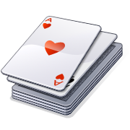**10s Go Fish**

This game is played just like "Go Fish." Instead of asking for a card to match your card, you have to ask for a card that would add with one of your cards to make a sum of 10. I made up this little cheat sheet to show the combinations that make 10. I laminated them to use again and again. The kids loved it so much they all wanted a cheat sheet to play it at home. Very quickly, the kids stopped using the cheat sheet.